Instructions to operate IRIS2 from the Front Plate Interface

# Procedure To Operate it

## Swich On:

* Put the Switch in the On position
* A GREEN LED will blink 5 times on the front plate
* Every 5 seconds the Green LED will blink (indicates correct operation of IRIS)
* Every 10 seconds a Blue LED will blink (indicates disk activity)
* When a picture is being made, a Red LED will be switched on

## Switch Off

* If the RED LED is On, wait for it to switch off (it will be between 5 to 15s)
* Put the switch in the Off position

Note: Red LED on indicates that the cameras are in operation, avoid switching off IRIS2 when the Red LED is on to avoid SDCards memory corruption

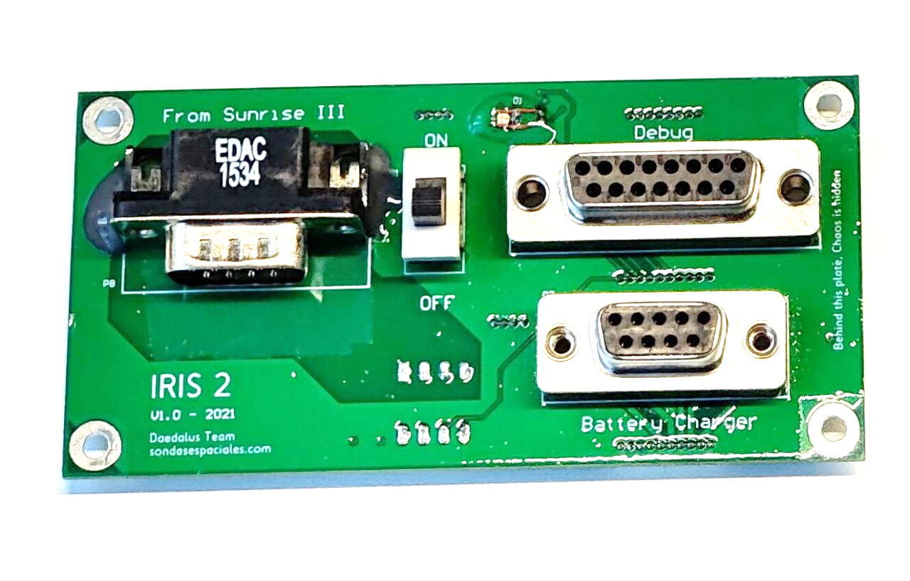

# Power to use the Cameras Externally

* Keep the Switch in the Off position always, even when IRIS is operated externally



* Connect the Debug DB connector
* Configure the power supply to 9V and 2A
* Make sure that the power Supply output is switched off
* Connect the Ground pin to the power supply
* Connect the Red cable to the power supply. Do not invert the cables because there is no protection!!

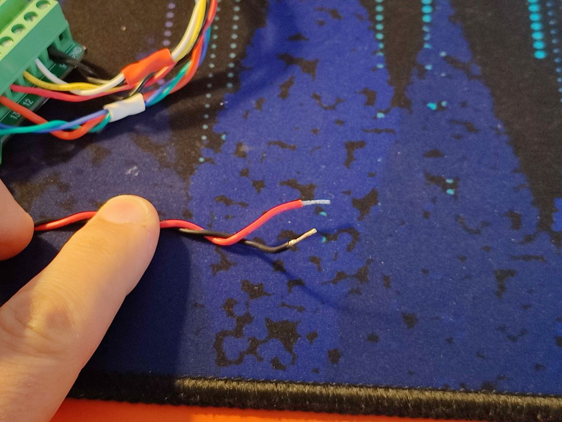

* Correctly identify the GND on the UART interface
* Check the continuity between the GND of the connector and the GND of the power supply

* Connect the UART pins as shown below:

* Connect the Launchpad to the USB
* Switch on Putty with the following configuration:
  + Connection type: Serial
  + Serial line: COMx (where "x" is the COM number in your computer that you can find in the "device manager")
  + Speed: 115200
* Switch on Power supply
* Terminal should show firmware version and welcome messages, leds should also power on
* The UARTs on the MCU have protection resistors, however it is recommended to not leave the UART port connected if IRIS is switched off.

# Programming the MCU with JTAG

* You should use two connectors:
  + The UART For the GND
  + The JTAG for the signal wires
* You have two options:
  + Without external power supply or batteries, provide 3.3V from the launchpad
  + With external power supply or internal batteries, never use the 3.3V from the launchpad!!!!
* You can have the JTAG and the UART connected concurrently for debug purposes without issues:
  + Using the 3.3V from the launchpad (however not enough power to switch on the gopros
  + Using the external battery (remember to disconnect the 3.3V of the launchpad)
  + Using the internal battery (remember to disconnect the 3.3V of the launchpad)

